# Overview

In this guided practice, you will configure Windows Server as a DHCP Server.

# Objectives

* Be able to install the DHCP service.
* Be able to start and stop the DHCP service from the GUI and command line.
* Be able to configure the DHCP Service to lease addresses for a specified subnet.
* Be able to configure the DHCP Service to hand out common TCP/IP options to DHCP clients, including:
  + Default Gateway, DNS Server(s), and Domain name.
  + Be able to create DHCP reservations.
  + Be able to create DHCP exclusions.

## Skills Reviewed

* Installing server roles on Windows Server.
* Configuring DHCP client.
* Verifying IP settings.

## New Skills

* Performing DHCP Post installation configuration.
* Creating DHCP scopes.
* Creating DCHP exclusions.
* Configuring common DHCP options.

## References

# Initial Conditions

* Guided Practice – Installing Active Directory is complete

# Instructions

## Installing the DHCP Role

The first step in setting up DHCP is to install the DHCP role on one of your servers.

Perform the following steps to install the DHCP server role on your Server-01 virtual machine:

1. Login to the **Server-01** virtual machine with a user with **Enterprise** **Admin** rights.
   * If you are not sure the account is a member of the **Enterprise Admins** group, you can type **whoami /groups** in PowerShell to see what groups your account is a member of
2. Add the **DHCP Server** **role** to the machine. Remember to include the management tools.
3. Login to the **Server-02** virtual machine with a user with **Enterprise Admin** rights.
4. Use **PowerShell** to **add** the **DHCP Server** **role** to the machine. Remember to include the management tools.

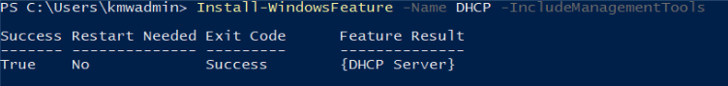

## DHCP Post-Deployment Configuration

Once DHCP is installed there are still a few tasks to complete. These include creating the DHCP Administrators and DHCP Users groups in Active Directory and authorizing the DHCP service in Active Directory. To do this perform one of the following below:

### DHCP Post-Deployment Configuration - GUI

1. Login to the **Server-01** virtual machine
2. 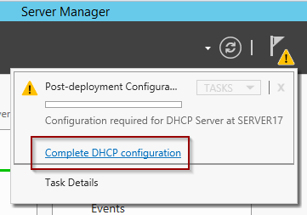Open **Server Manager**, click the **Complete DHCP configuration** in the message in the notifications window.
3. On the **Description** page of the **DHCP Post-Install configuration** **wizard**, read the information and click **Next**.
4. On the **Authorization** page of the **DHCP Post-Install configuration** **wizard**, verify that **kmw\kmwadmin** is shown in the Username: text box under the Use the following user’s credentials option. Then click the **Commit** button.
5. On the **Summary** page of the **DHCP Post-Install configuration** **wizard**, review the summary and click the **Close** button.

### DHCP Post-Deployment Configuration – Powershell

1. Login to the **Server-02** virtual machine with a user that is a member of the **Enterprise Admins** group.
2. In **PowerShell**, type the following command:

Add-DhcpServerSecurityGroup

Add-DhcpServerInDC -DnsName DC-02.kmw.local

1. **Note**: You did not have to run the first command as it only needs to be run once per domain to add the necessary security groups in Active Directory.

### Verifying DHCP Post-Deployment Configuration

1. Verify the configuration is correct by typing the following commands in PowerShell: Your output should look like the figure below:

Get-DhcpServerInDC

Get-ADGroup -Filter “name -like ‘*dhcp*’”

1. Your output should look like the figure below:

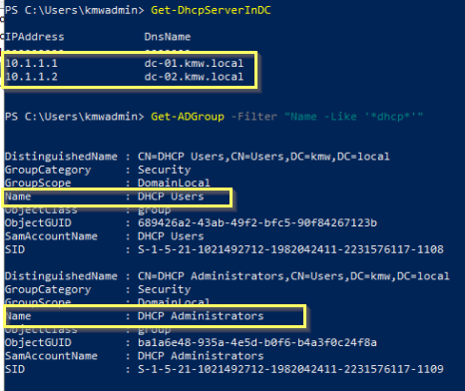

## Creating and Configuring a DHCP Scope Using the GUI

To assign TCP/IP configuration information to DHCP clients, you must first create and activate a DHCP scope. This will configure a range of IP addresses to lease to clients and configure some common TCP/IP settings like the default gateway, DNS servers, and Domain name.

Create a DHCP scope using the GUI by performing the following:

1. Login to the **Server-01** virtual machine with the **kmwadmin** account
2. Open the **DHCP** management console from the **Tools** menu in **Server Manager**.
3. 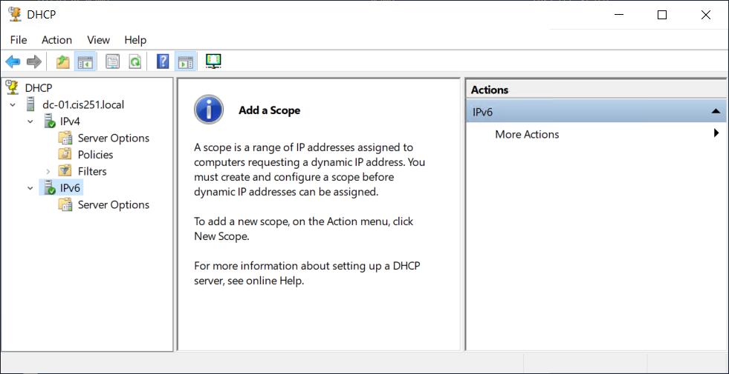In the **DHCP** management console expandall the nodes. The console should look like the figure below:
4. 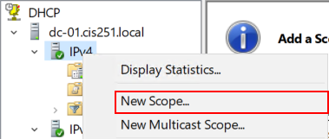Select **New Scope**… from the context menu for the **IPv4** node as shown in the image. This will launch the **New Scope Wizard.**
5. On the **Welcome to the New Scope Wizard** page of the **New Scope Wizard**, click **Next**.
6. On the **Scope Name** page of the **New Scope Wizard**, type **KMW-LAN** in the **Name:** text box and click the **Next** button.
7. On the **IP Address Range** page of the **New Scope Wizard**, type the following and click **Next**.
   1. Start IP address: **10.1.1.1**
   2. End IP address: **10.1.1.254**
   3. Subnet Mask: **255.255.255.0**
8. On the **Add Exclusions and Delay** page of the **New Scope Wizard**, type the following and click the **Add** button.
   1. Start IP address: **10.1.1.240**
   2. End IP address: **10.1.1.254**
9. Repeat the process above to exclude the addresses below.
   1. Start IP address: **10.1.1.1**
   2. End IP address: **10.1.1.10**
10. On the **Lease duration** page of the **New Scope Wizard**, click **Next**.
11. On the **Configure DHCP Options** page of the **New Scope Wizard**, verify the **Yes, I want to configure the options now** option is selected and click the **Next** button.
12. On the **Router (Default Gateway)** page of the **New Scope Wizard**, type **10.1.1.254** in the **IP Address** field and click the **Add** button. Then click the **Next** button.
13. On the **Domain Name and DNS Servers** page of the **New Scope Wizard**, **verify** that **kmw.local** is shown in the **Parent domain**: text box and **10.1.1.1** is listed in the **IP address:** text box. Click the **Next** button.
14. On the **WINS Servers** page of the **New Scope Wizard**, click the **Next** button.
15. On the **Activate Scope** page of the **New Scope Wizard**, verify the **Yes, I want to activate this scope now** option is **selected** and click the **Next** button.
16. On the **Completing the New Scope Wizard** page of the **New Scope Wizard**, click **Finish.**

## Creating and Configuring a DHCP Scope Using Powershell

Perform the following on **Server-02**.

DHCP can also be configured using PowerShell. To determine the commands available, type the following in PowerShell:

Get-Command -Name *dhcp*

A partial listing is shown below. Notice the module name for these commands. All the commands are located in the **DhcpServer** module.

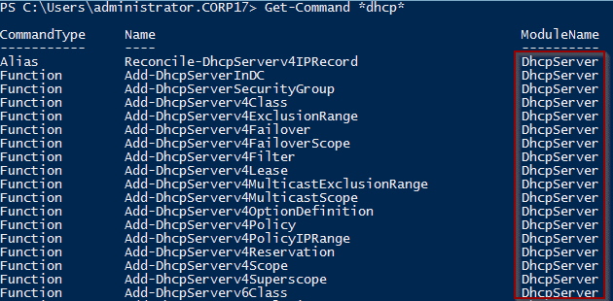

Type the following command to view the PowerShell commands for viewing DHCP information:

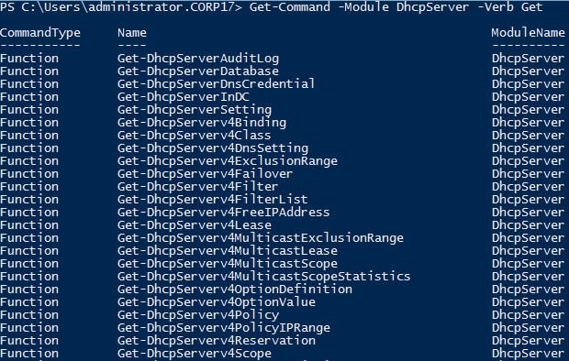Get-Command -Module DhcpServer -Verb Get

Type the following command to verify the scope you configured in the GUI.

Get-DhcpServerv4Scope -ComputerName DC-01

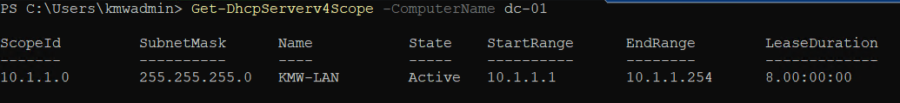Your output should be like that shown below. (**Note**: your output should have different information in the second octet of your addresses.

To use PowerShell to add a DHCP Scope for the 10.2.2.0/24 subnet with the following settings, perform the following:

* + Scope Name: **BUILD-LAN**
  + Starting IP address: **10.2.2.1**
  + Ending IP address: **10.2.2.254**
  + Subnet Mask: **255.255.255.0**
  + Default Gateway: **10.2.2.254**
  + Exclude the address range: **.240 to .254**

1. Create the DHCP scope by typing the following:

Add-DhcpServerv4Scope -Name Build-LAN -StartRange 10.2.2.1 -EndRange 10.2.2.254 -SubnetMask 255.255.255.0

1. Exclude the required addresses in the scope by typing the following:

Add-DhcpServerv4ExclusionRange -ScopeID 10.2.2.0 -StartRange 10.2.2.240 -EndRange 10.2.2.254

Add-DhcpServerv4ExclusionRange -ScopeID 10.2.2.0 -StartRange 10.2.2.1 -EndRange 10.2.2.10

1. Use the command above to exclude the addresses between **10.2.2.1** to **10.2.2.10**.
2. Configure common DHCP options by typing the following:

Set-DhcpServerv4OptionValue -ScopeID 10.2.2.0 -Router 10.2.2.254 -DnsDomain kmw.local -DnsServer 10.1.1.1

## Verifying DhCP Configuration USING the GUI

Perform the following **on** **Server-01**.

To verify your configuration, perform the following:

1. In **Server Manager** and open the **DHCP** management tool from the **Tools menu**.
2. Browse to the **DHCP** **Server→dc-01.kmw.local→IPv4 Node**
3. In the **Scope** node, verify the network address and name of the scope.
   1. You can change the name of the scope from the properties page of this node
4. In the **Address Pool** node verify the starting and endingIP addresses and the exclusion ranges.
5. In the **Address Leases**, there should be no clients listed. This will be empty until you hand out an IP address
6. In the **Scope** **options** **verify** that you have values for: (These options can be configured from their properties page)
   1. **Router** →This is the default gateway for your clients.
   2. **DNS Servers** → These are the DNS servers for your clients.
   3. **DNS Domain Name** → This is the DNS domain name for you clients.
7. In the Server Options verify that you have no values.

## Verifying DHCP Configuration using PowerShell

1. Verify the **scope** **settings** by typing the following on **Server-02**:

Get-DhcpServerv4Scope

1. Your output should be like the image below:

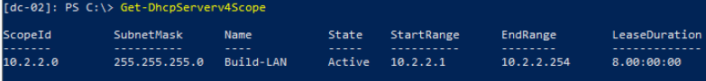

1. Verify the exclusions by typing the following:

Get-DhcpServerv4ExclusionRange

1. Your output should be like the image below:

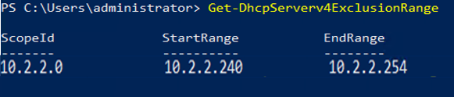

1. To verify the scope options, type the following:

Get-DhcpServerv4OptionValue -ScopeID 10.2.2.0

1. Your output should be like the image below:

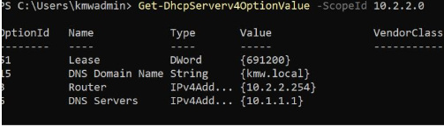

## Configuring a DHCP Client

1. Logon to your **Client-01** virtual machine using an administrative account.
   1. Configure your network adapter to use DHCP
   2. Verify that your client received an IP address setting from your server
2. Logon to your **Client-02** virtual machine using an administrative account.
   1. Configure your network adapter to use DHCP
   2. Verify that your client received an IP address setting from your server

## Submission Requirements

1. **Download** the **grading** **script** from the assignment page to the **C:\Scripts** folder.
2. Check your lab by running the following command:

Invoke-Pester -Path C:\Scripts\GP13-Installing_and_Configuring _Windows_DHCP.test.ps1

**Note**: You will see a security warning when running the script. Enter **R** to run the script.

If you want to see more detail, add **-Output Detailed** to the command. This may assist you with troubleshooting

Invoke-Pester -Path C:\Scripts\GP13-Installing_and_Configuring _Windows_DHCP.test.ps1 -Output Detailed

1. You should not see any red in the output. Red in the PowerShell way of telling you that an error condition exists. Most of the time, the output will tell you what is wrong. If it is not obvious, contact your teacher and ask for assistance. You will be learning PowerShell during this term. **Correct** any **errors** you may have and run the script until all the output has no red. You should see the output like the images below

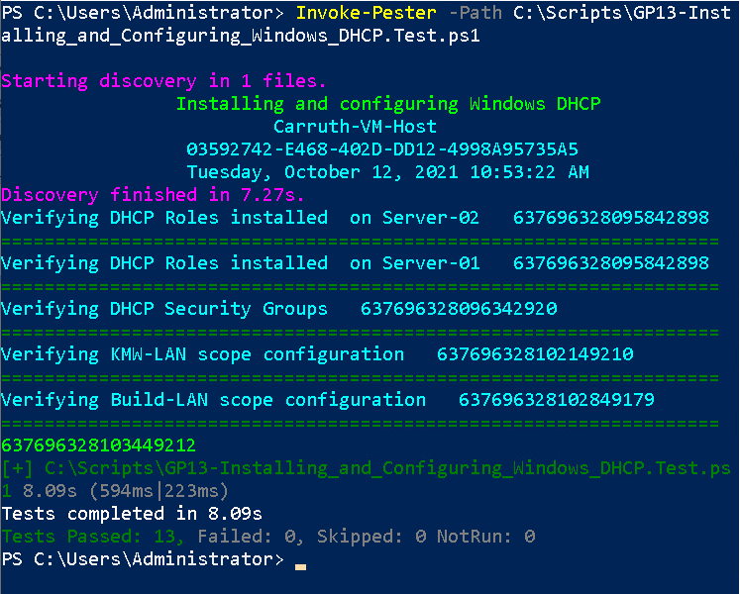

1. Capture a snippet that shows the PowerShell Command and all its output. If you must use more than one snippet to capture the output, you must have at least **one line of overlap** in the snippets. The text in the snippets **must be legible** when pasted into the Word document. Paste the snippet(s) into a **new** **Word** **document**
2. **Fill** **in** the **information** in the following table. Copy the following table into the **Word** **document** and fill in the information about all the **new** commands used in this lab (the example provided is not a new command and should be deleted):

|  |  |  |
| --- | --- | --- |
| PowerShell Commands | | |
| Command | Example | Description |
| *Get-Childitem* | *Get-Childitem -Path C:* | *Displays the files in the C:\ directory* |
|  |  |  |
|  |  |  |
|  |  |  |
|  |  |  |
|  |  |  |

1. **Upload** the **document** in the submission area of the assignment.